100 DAYS OF CODE
DAY-1
Q1 (User Inputs, Operations & Output)
Write a program to input two numbers and display their sum.
Show Sample Test Cases

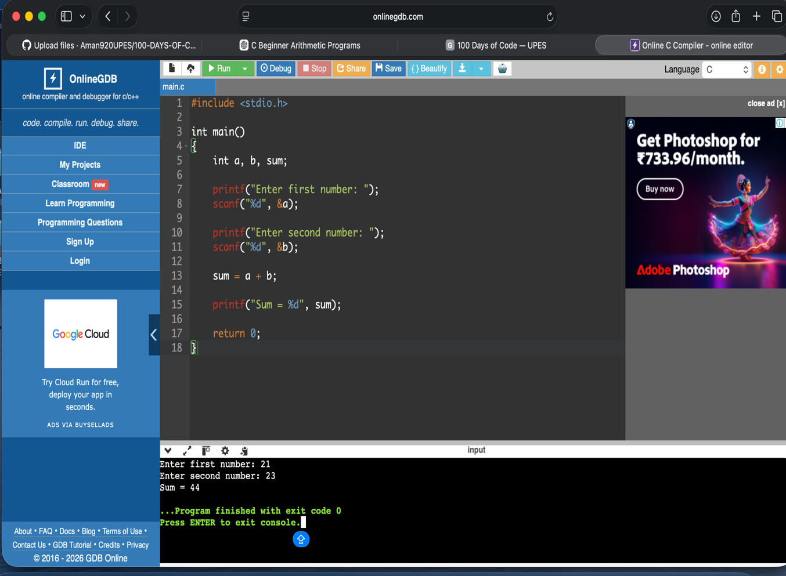

Q2 (User Inputs, Operations & Output)
📋
Write a program to input two numbers and display their sum, difference, product, and quotient.
Show Sample Test Cases
Division by zero should be handled carefully.
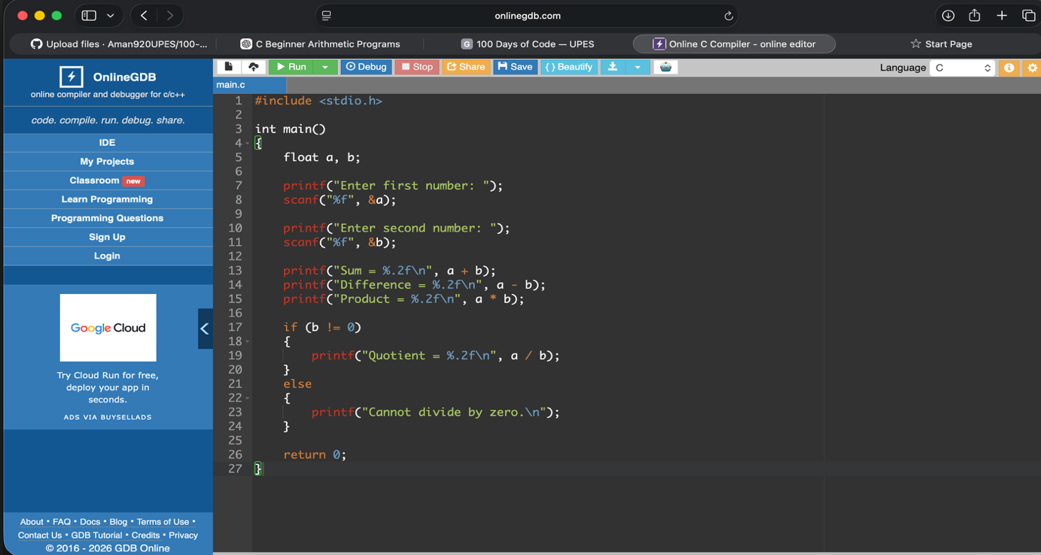
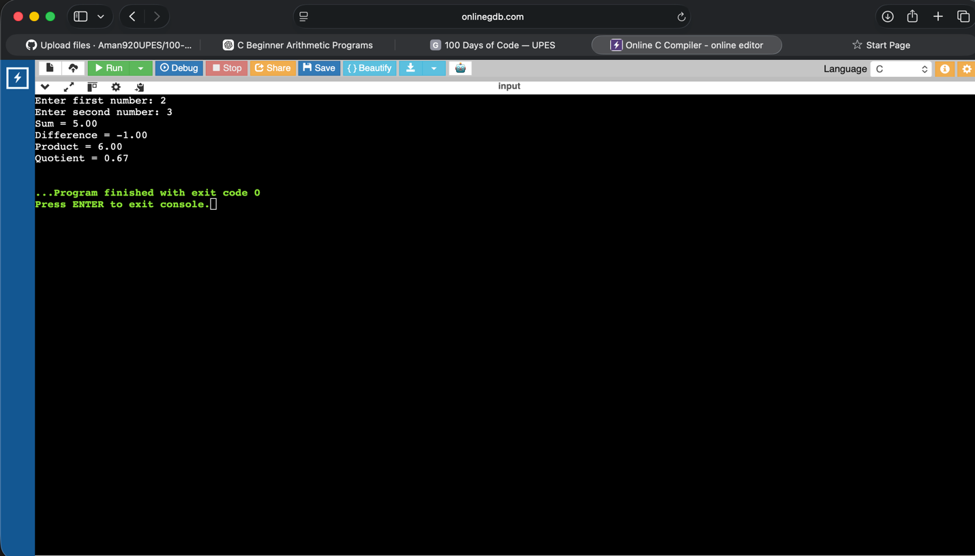
DAY-2
Q3 (User Inputs, Operations & Output)
📋
Write a program to calculate the area and perimeter of a rectangle given its length and breadth.
Show Sample Test Cases

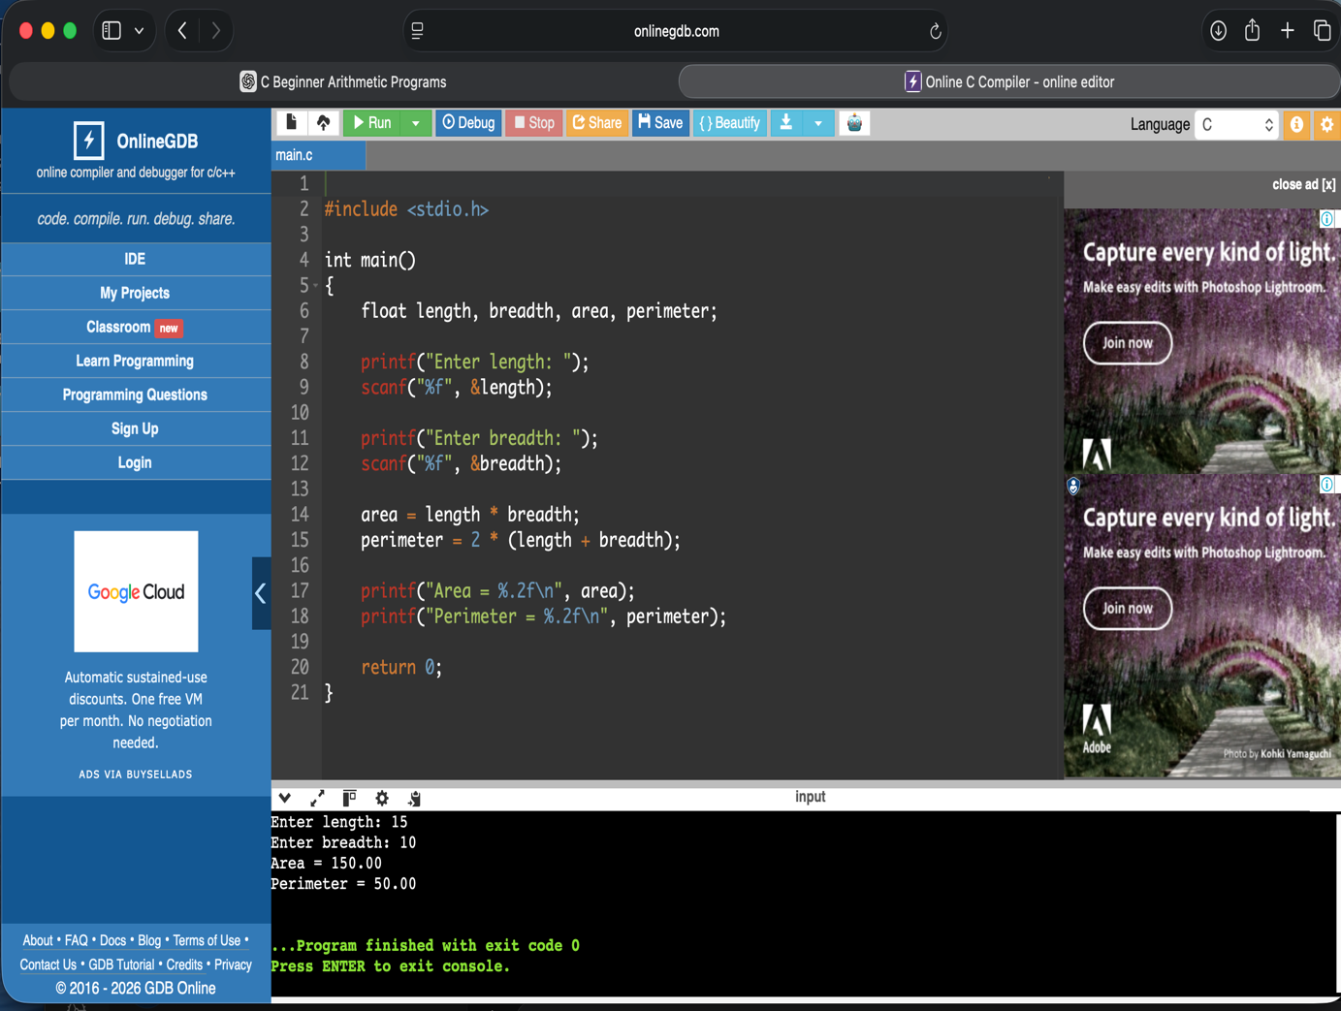

Q4 (User Inputs, Operations & Output)
📋
Write a program to calculate the area and circumference of a circle given its radius.
Show Sample Test Cases

